UNIVERSITY OF BOLOGNA

Practical guide for completing the application on the PICA platform

Registration and access:
The first step is to access the platform website through your browser by clicking on the link https://pica.cineca.it/login, or on the link in the call for applications.

On first accessing the platform, you will need to register by clicking on the “New Registration” button and following the steps necessary to create your own account. If you are already registered, simply click on “login” and enter your username and password.

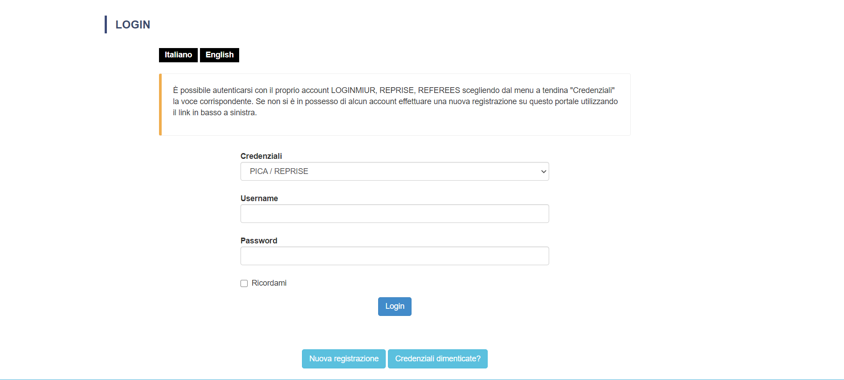

As of April 2021, access is possible using SPID (public digital identity system) credentials. Users in possession of a digital identity can click on the relative box on the right-hand side of the aforementioned field in order to access the system using their MIUR or PICA/REPRISE login.

For newly registered users, to confirm the creation of your account, follow the instructions given in the email that will be sent by the system following registration. If you do not receive this email, contact the support service by sending an email to: unibo@cineca.it

Completing the application:
Having accessed the platform, all the open procedures for which it is possible to submit an application will appear.
Once you have selected the procedure you are interested in, a web page will open where you can complete the application by clicking on the relative button.

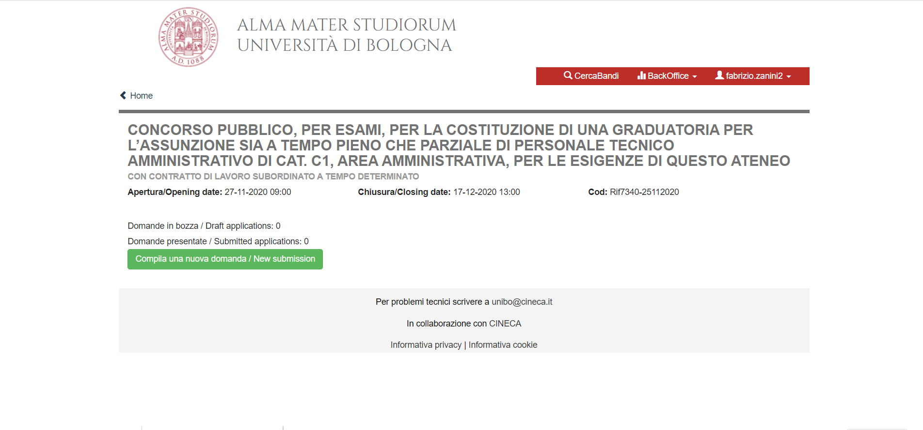
The application form is divided into seven sections, each of which requires you to enter data that is mandatory and/or optional, and in some cases, to upload documents.

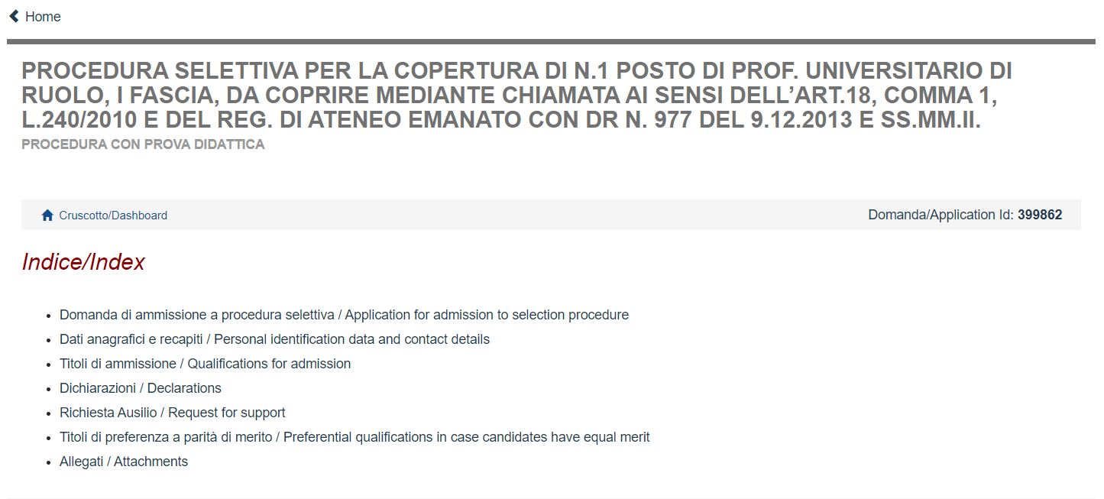

The mandatory fields are clearly indicated and cannot be ignored if you wish to proceed with the application. An example is given below:

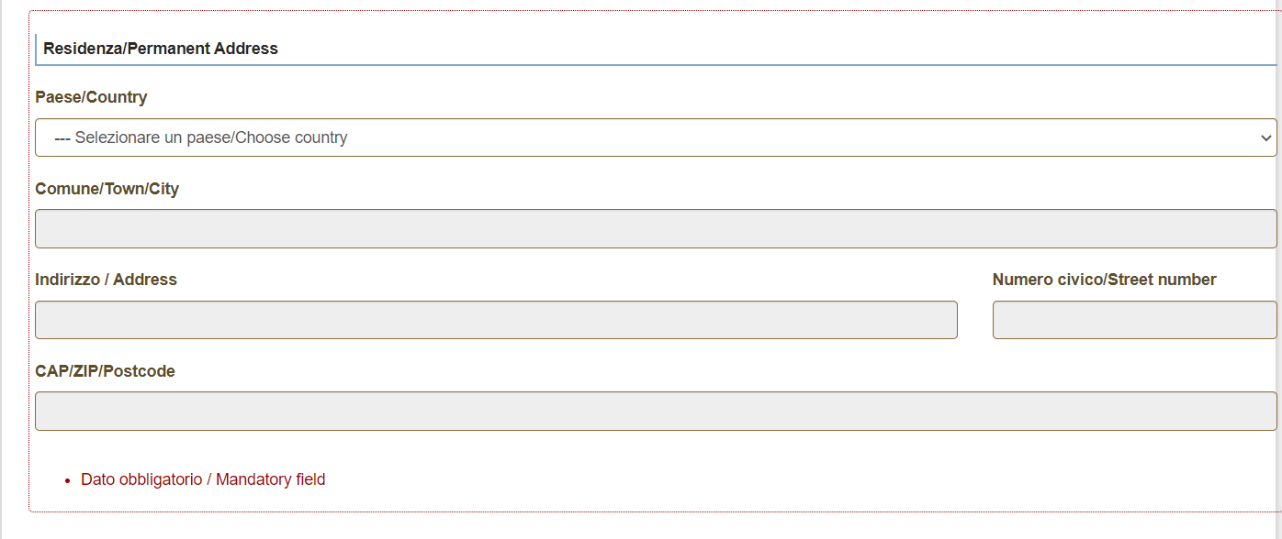

At the end of each section, there is a button to click in order to save the data entered and to proceed to the next section.

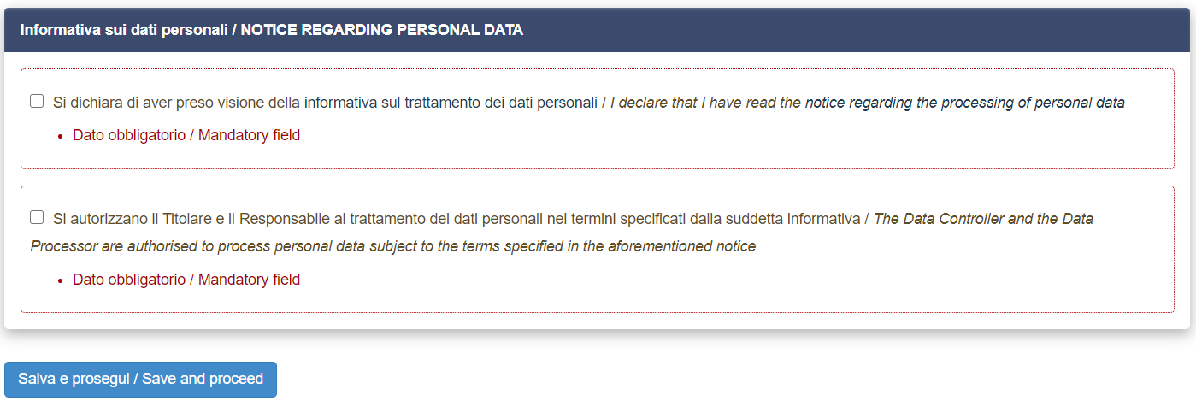

Once you have filled in all the fields, uploaded any required documents and accepted all the conditions, you must save your application by clicking on “save and back to the dashboard”.
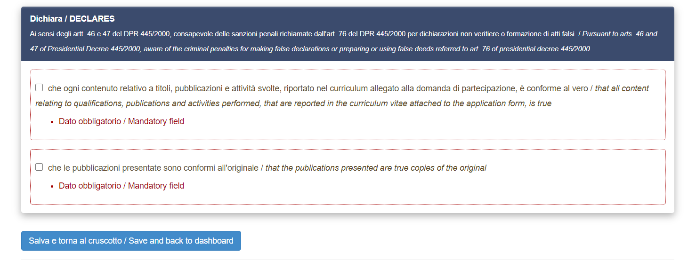

Submitting your application:
At this point, you will have produced a draft application to which an identification number is assigned. The draft application, regardless of whether it is complete, is not sufficient in itself for admission to the procedure.
With your application saved in draft mode, you then have the following options: edit your application (click on “edit”), check your application (click on “verify”), or submit your application (click on “submit”).

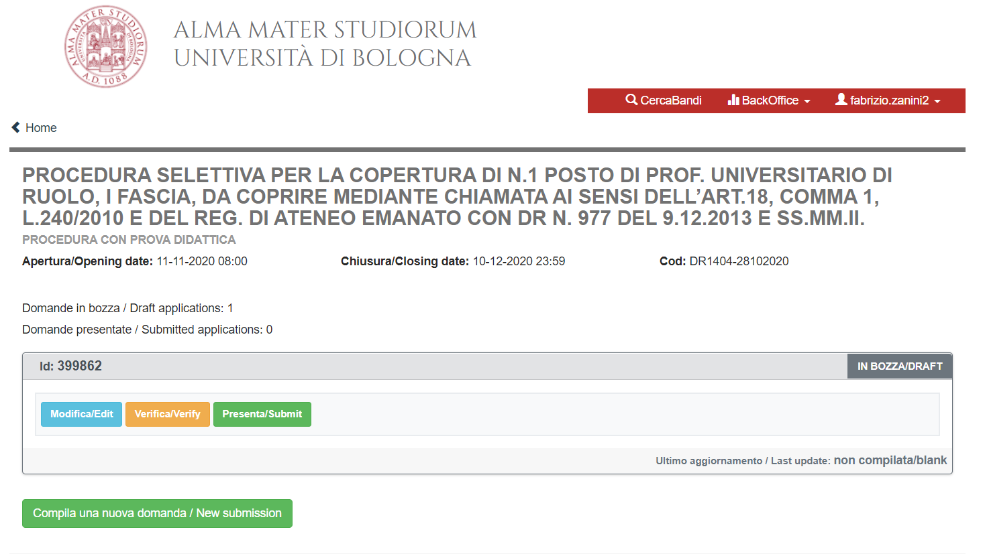

You may only submit one application for the same procedure.
If you are certain of the data and documents entered and wish to proceed with the application, you must click on “submit”.
Having done this, a new page will open with a summary of the application completed.
Warning. A warning message may appear indicating that the application has not been sent. In this case, the system will indicate one or more reasons why the application cannot be submitted such as in the following example:

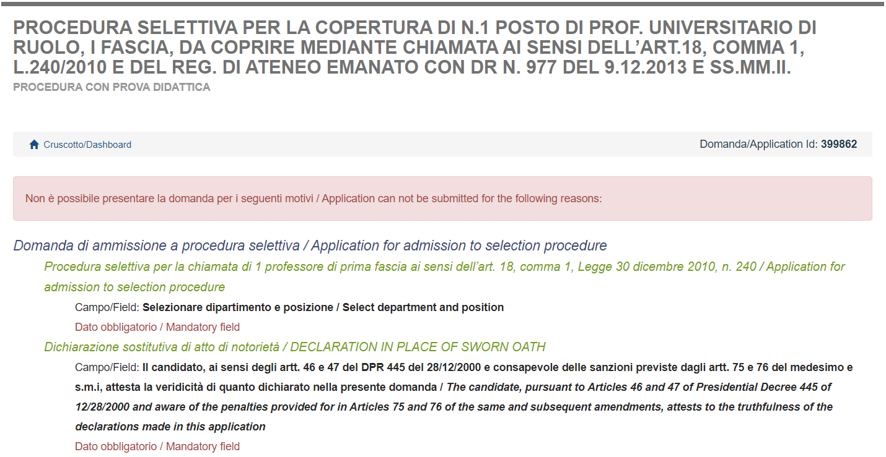

If and when there are no reasons preventing submission of the application, the “submit” button will appear at the bottom of the aforementioned summary page.

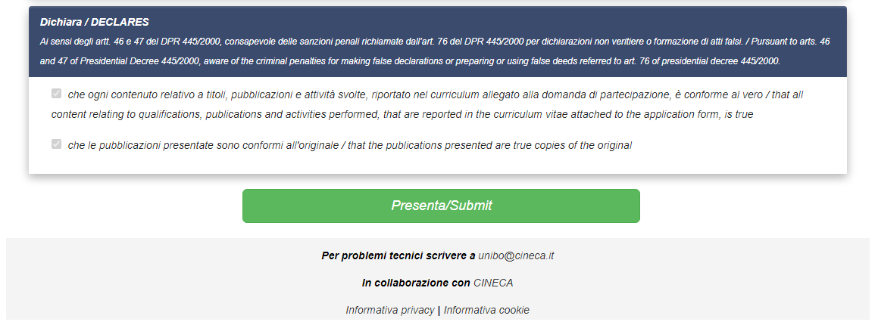
The status of your application will only change from “draft” to “submitted” once you have clicked on this button. If you do not complete this important step, you will not be considered as a candidate for the procedure.
There are, however, various safeguards to ensure your participation in the procedure. First of all, once you have clicked on “submit” the system will provide confirmation that your application has been submitted.
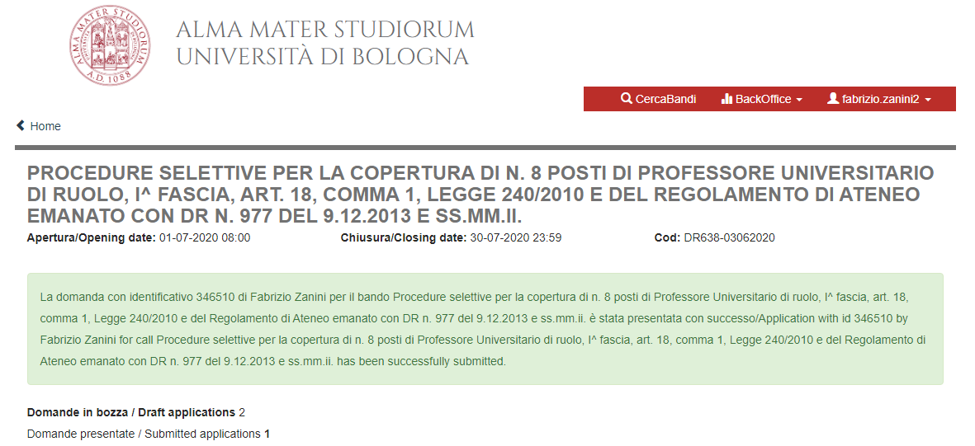

Furthermore, on returning to the dashboard, you can check that the status of your application has changed from “draft” to “submitted”. Below are three distinct fields: the first two applications have not been sent, while the third one has:

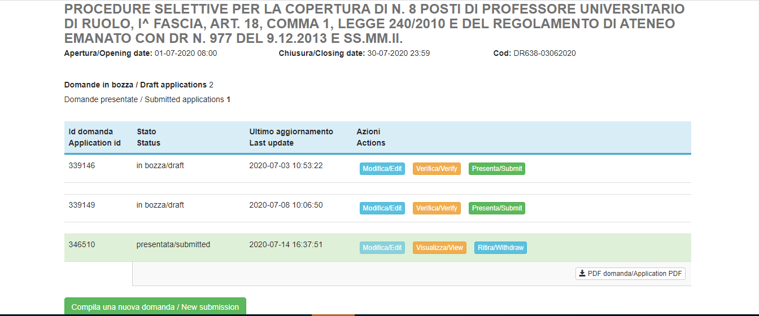

You will also receive an email, sent from the platform, confirming the submission of your application and containing your application identification number.

At this point, it will no longer be possible to amend your application. Indeed, once applications have been sent, it is not possible to change and/or add to the information already sent. The only option available is to withdraw your application by clicking on “withdraw” and then, if necessary, complete and submit a new application.

If you wish to pursue this option, you must take care to ensure you meet the deadlines indicated in the call for applications. If you decide to withdraw your application once the deadline has expired, you will obviously not be able to submit a new application and the administration will assume that by taking such action, you have decided not to participate in the selection procedure.
You are reminded that, in order to complete the application process, you must follow all the above steps and check that you have received confirmation online and via email that your application has been submitted.
The offices in charge of the procedure and the Selection Committee will take into account only that which is contained in the application.

Please note that this guide contains general and partial information. It neither replaces the indications set out in the calls for applications nor offers a detailed description of all the possible scenarios.
In this regard, for further clarification on how the PICA platform works or if you encounter any problems while using it, you can ask for help by sending an email to unibo@cineca.it

